# Noodli Noodles

# Why Noodles?

Noodles are one of the hottest and best-selling fast moving consumer goods (FMCG) in the current market with consumers ranging from small children to elderly people. Everyone has a taste for these noodles. We will sell noodles that are cheap, readily available and available in a variety of flavours to choose from. Our contemporary logo and company culture will surely attract the newer generations and this is what we plan as an organization to bank upon.

# Noodli: What does it mean?

Noodli is derived from the amalgamation of an English word: Noodles and a slang word: Foodie. The combination of these words leads us to Noodli. Our brand loves food and respects the art of culinary. We want to create the noodles that will tingle the taste buds of all those who devour them, making them want more and more. Our noodles will be the best on the market in terms of taste and will entice the noodle loving community and all foodies to consume our fabulously scrumptilisious Noodli Noodles.

# Our Logo

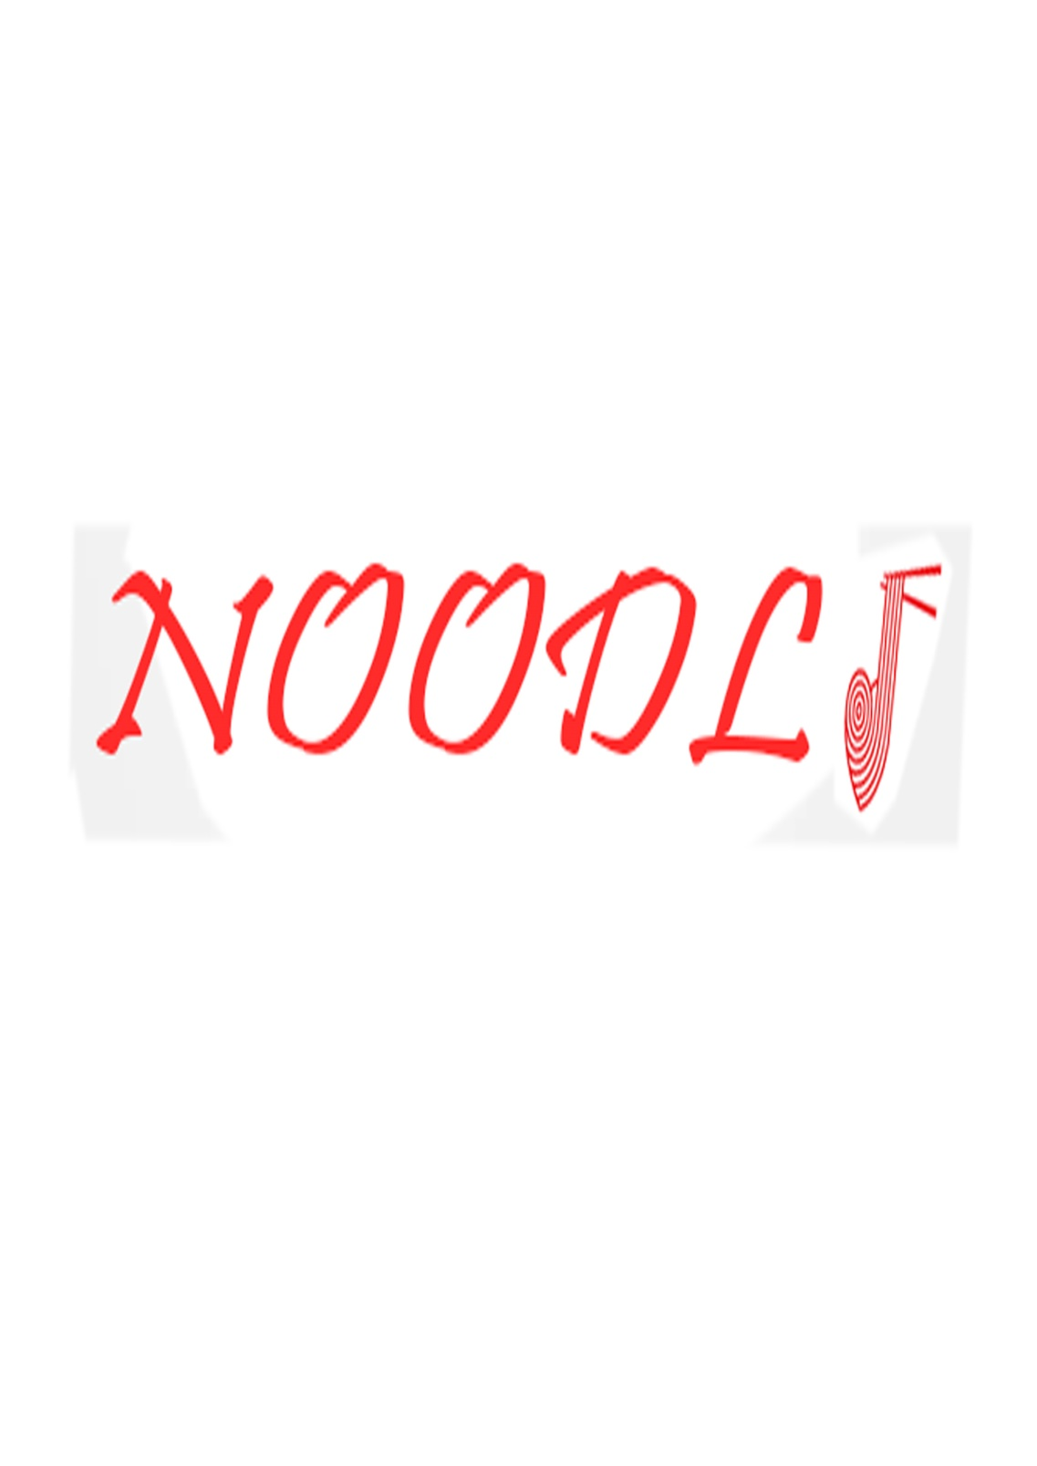

# Tagline

*Let’s Slurp !!!* : Our official tagline is both catchy and meaningful. It relates directly to the industry we pertain in and can be easily spoken and used on short context for advertising purposes also.

# Our Range Of Products

# Noodli Masala Noodles

# Our Noodli Masala Noodles will be our main product and best-seller. They will cater to all crowds, be it children, college going students, young adults or even the elderly. With just enough spice and just enough tang they will be perfect.

They will be packed in various configurations with the base unit (smallest unit) weighing 70 grams and other packs of 2, 4, 6, 8 and 10. They will be priced at around Rs. 10 for the basic 1 cake packet.

# Noodli Chatpata Noodles

This will be another iteration of the Masala Noodles, but with more spice. This will cater to audience above the age of 25. People who have a similar taste, and are our target audience for this packet of noodles have to purchase extra Maggi Masala along with generic Maggi to get a spicier version of normal Maggi, so we want to eliminate this work around that the people have created for themselves, by providing to them directly this tangier version Noodli Masala Noodles.

# C:\Users\Family\Projects\Management Project (MG - 2017) - Noodly\Logo Images\NOODLI 3.jpgNoodli Chinese Twist Noodles

There is rave going on in the current market and a new Chinese taste is being developed in both the younger as well as contemporary crowd. To tap into this Chinese taste market we will be launching the Noodli Chinese Twist Noodles which we are sure will be absolutely adored by all lovers of Chinese food. This will be one of a kind product, as generally the current Chinese’s noodles present in the market, be it by any manufacturer require a a lot of preparation and our instant Chinese noodles will be instantly loved.

# Noodli Chicken Noodles

There is a big portion of the market that loves chicken noodles, but there is no definitive company prevalent in this space of the Industry. Maggi does make chicken noodles, but they are very expensive and hence a commodity not available for the normal public. There is also a shortage on their availability, as they are not easily found in any of the local grocery shops, but have to be head hunted out of any of the big food marts, which is the reason that this demographic of the market has not been completely satiated. Our product will undercut all the previous marks set be any of the company and be one of our primary products (if not the main) and will be just s readily available as our mainstream Masala Noodles, which would pave our way into this industry, by creating a loyal user base out of the chicken loving Noodles demographic.

# Target Audience

Defining an appropriate target audience is the secret behind the success of any enterprise; it can make or break the very fortunes of the company. The right target audience will enable us to analyse consumer tastes and come up with competitive products and pricing.

Noodli aims to target college students, the ones living in hostels and PG accommodations. Food in hostels is often not of good quality, and outside food is expensive. Hostel students need delicious food which can be rustled up very easily, without compromising on health standards. Noodli serves the exact purpose.

Noodli is also great for children and adults of all ages. It is healthy, delicious and easily digestible. Its composition has been thoroughly researched upon, and has been verified by various food standards of testing to be completely safe and free of toxins and chemicals.

Noodli has the added advantage of being inexpensive and very easily to make, so anyone in a hurry can quickly make up a delicious cup of noodles and slurp their way to work!

Be it serving guests or a midnight snack, Noodli can serve all purposes and fit your idea of a delicious snack. Our target audience will be researched upon properly and appropriate flavours and prices will be developed and proposed.

# Labelling and Packaging

At Noodli we truly believe that food is eaten by the eyes before it is tasted by the tongue and the way we present it does matter. Our top global designers have worked relentlessly to create our distinct logo that our customers can easily identify in the plethora of other fast food companies that exist as our competitors.

We have made sure that our logo and tagline and creative advertising techniques will differentiate us from the crowd and give us our own platform through which we will cater this large pool of customers.

We will not use Lead (Pb), Mercury (Hg), arsenic (Ar) or Silicon (Si) in any of our products or packaging and our operations will be completely legal and friendly for the environment. Our packing will happen in safe environments for the labourers that will work in our factories. Our products will be manufactured and packaged on separate floors to ensure smooth functioning of the factory unit, but will take place in the same factory to increase productivity.

Our packets will contain all the information regarding nutrition facts, factory address, manufacturing address as well as our HR contact information on the packet itself. We are aware that the customers of today want to know all about their products, especially eatables before making a buying decision and we will be very transparent with our consumers.

## Nutrition facts (in 275 gms)

|  |  |
| --- | --- |
| **Calories** | 380 |
| **Total Fat** | 16 |
| Saturated | 2 |
| Polyunsaturated | 2 |
| Monounsaturated | 9 |
| Trans | 0 |
| Cholesterol | 1 mg |
| **Sodium** | 957 mg |
| **Potassium** | 121 mg |
| **Total Carbs** | 51 mg |
| **Dietary Fibre** | 0 |
| **Sugars** | 0 |
| **Proteins** | 8 g |

# Product Prices

We are entering this market which already has several noodle brands in it. The market is congested and not hospitable to newer entries, but we believe that there is a large section of the market that is still untapped and that we can gain foothold in this tough market with good advertising, high quality products and by competitively pricing ourselves with our competitors for the first few initial years.

There are not many chicken noodles in available in the market landscape as of now. Nestle has chicken noodles with its Maggi chicken noodles, but they are not widely available `in grocery shops and have to be purchased from upper scale grocery marts, and even there the stock is not that fresh. We plan to launch our own Chicken Noodles which we believe will be one of the major, if not primary factors in pushing us forward in this industry. Our chicken noodles will be tasty, cheap and readily available and will be the first of it’s kind in this segment to be so widely available. We will develop a very loyal customer base that relishes chicken noodles, but haven’t had any real options until yet.

The Maggi chicken noodles are priced at Rs. 14.55 for the 70gm pack. Our product will be priced at Rs. 12 for the same amount. Our production cost of one packet will be around Rs.6 to Rs. 6.48. This is how we plan on undercutting Maggi and establishing ourselves as a player for a particular audience and also capturing the interest of the chicken loving community whilst earning a decent profit for ourselves.

Our other major product is the Noodli masala noodles and we will focus this majorly to the college going crowd and students living in PG’s and hostels. The students are always short of funds and want a tasty and affordable snack food item which is exactly what we will provide. Maggi currently sells their masala noodles at Rs. 12 for the 74gm packet. We will sell the same packet for Rs. 10 and win over this crowd. We will also run dedicated PR drives in colleges to woo over their canteens and messes with our products and this will soon create a Halo effect and lead to the success of our product.

We also 2 more flavours planned in our line-up, which are ‘Chinese Twist Noodles’ and ‘Chatpata Noodles’. Each designed specifically for a certain demographic of the consumer base. Our analysts believe that we will gain about 30 – 34 % of the market share within 3 years of launch.

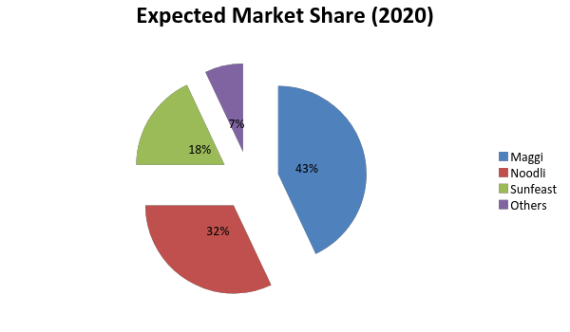

# Channels of Distribution

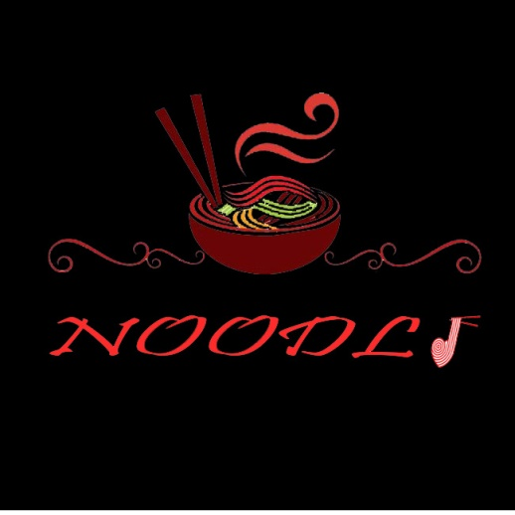Our company wants to establish a strong channel of distribution throughout the subcontinent and fast and we have a well-structured plan for every region pertaining to its demographic to penetrate with our products as deeply as we can.

# Urban Areas

We will market and distribute our product in the urban areas using a network of Super Markets and grocery shops which are widespread in every locality and housing colony. We will advertise our products in these shops using colourful and eye catching banners. We can also provide stalls and other material that is helpful to these shops with our company name and logo on top.

# Colleges / Campuses / Universities

We will convince the college canteens and messes to switch over to our products by providing them samples and showing them how we are a cheaper alternative to the one they are currently using. Once our customer, we will make regular deliveries to theses colleges with our product. These institutions currently have to make the effort of locating the food themselves from the grocery shops nearby, but this is something we will change by providing service to them and delivering our products directly to their doorstep. This will surely make an impact and turn them into one of our loyal customers.

# Suburban / Rural Areas

Entering the rural market will be tough, but we will also enjoy the benefits if a foothold is made in that particular market. We will distribute to rural areas and suburban areas by using a network of kirana shops. These kirana shops will sell our noodle products exclusively and for that we will provide them with front banners for their shops, with our advertisement on top. This will guarantee us monopoly over several areas with limited investment into that particular region.

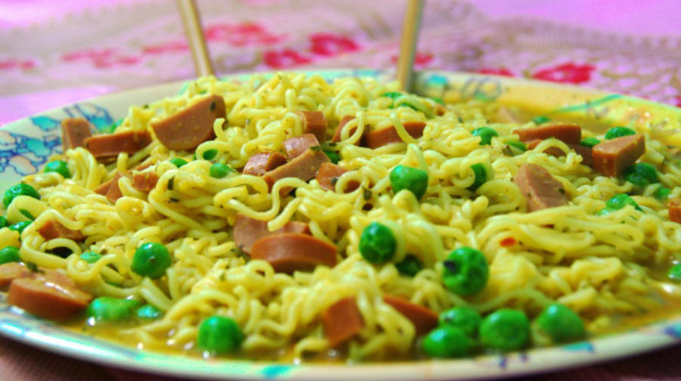

# Warehousing and Transportation

Our company knows that only by properly warehousing the raw materials, establishing an efficient management and production process for the final product and by further warehousing and distributing the product with order can we achieve the market share that we are aiming for.

Warehousing is essential for any company manufacturing in such large quantities as we will be when we hit full operational capacity within 5 months of operation time, but warehousing also costs money and space So our company wants to achieve the perfect balance wherein we do not under supply our products, but also not work our factory In higher than required capacity, such as to create surplus of stock only to leave us vulnerable to losses.

We will manufacture our product in several factories distributed throughout India at the same time, so as to minimize Transportation cost. The product will be manufactured and packaged at the same site, but will happen in separate staging areas inside the same factory to increase productivity and minimize labour.

Our initial plan is to set up a factory in the Okhla area near Delhi, which will provide us a strategic vantage point consisting of Noida, Delhi, Gurugram and the NCR region. Further factories are 3 in Punjab, which will provide tactical advantage over Himachal Pradesh and Haryana and this way we will have a distributed network over India starting with 11 factories and slowly moving up to 37 operational factories within 3 years.

Transportation is necessary to get our product delivered to sellers and resellers which will finally reap profit. As a company we want to create a certain image of ourselves in the market and we want that image to consist of good paymasters and excellent deliveries. We want to ensure that all our deliveries happen o time, and keep our customers satisfied. This will ensure that we get paid upfront for all our deliveries, as the distributors would have faith on our delivering prowess.

This we plan to achieve by carefully managing and scientifically timing our delivery speed in various regions and environments and then reducing our transportation time and expense by training our employees, instead of just plainly hiring them and the retaining them to form a skilled task force with high problem solving ability rather than a semi–skilled force working on a contract.

Our transportation system would originate within each factory and spread and connect all our warehouses and cities in a strategically planned manner to obtain one of the fastest transportation networks within any organization.

Our transportation team will start off with one truck for every factory and a few small Tempos, but then grow as the factories and operational capacity increases to about 4 trucks per factory and a fleet of smaller trucks.

# Advertisement

Advertisement is the backbone of any start-up and we need to invest in advertising to get our product of the ground. Advertisement needs to happen strategically and in a well-planned manner to encompass our efforts that we are putting in the creation of the product.

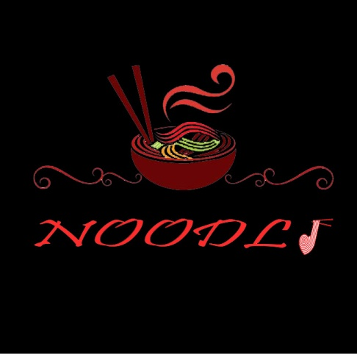 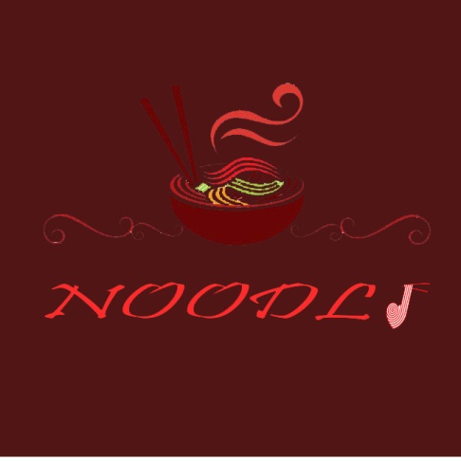 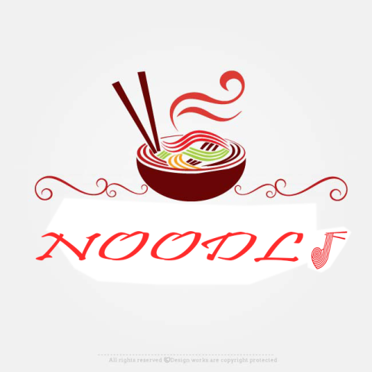

***Our Distinct Logo for Our Group of Products***

To start off we will get a B grade celebrity endorsement for our product. We will use a very catchy tagline for our advertisement and complement it with the chosen celebrity. The celebrity advertisement will then be used on all our print collateral, advertising, social Media and other channels associated with our product.

We will also set up booths in some upper-middle-class colonies and give out free samples to people. This will surely attract a crowd and win new customers.

The next and obvious step with our advertisement will be TV advertisements, which will be really costly ad hence short. We will also advertise on social media platforms by having online competitions and sponsoring small online events. This way we will create an online presence.

We will also approach colleges and sponsor their events on a small level. We will also have our events in these colleges and set up a booth for tasting there as well, and try and win over the campus crowd in this fission.

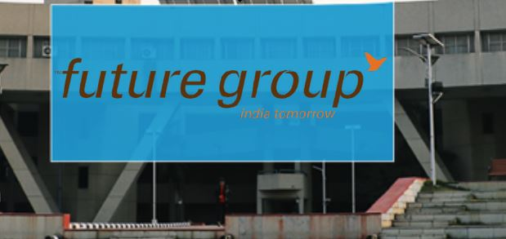

***How Our Sponsorship Will look like (This is a generic Poster)***

We can also serve our noodles as small cup-noodle packs in events such as concerts; plays etc. and we can also start to provide such small cups to airlines which need to provide small servings or snacks. This will help portray our brand in excellent light as well as start to give returns.

As the business expands we can start to sponsor larger events such as cricket matches etc. and change the level of our outreach completely. That is the point where our business will eclipse and grow explosively.

We need a similar, yet different approach for the suburban areas, in the suburban areas we plan to provide small shops with good quality plastic boards for their shop displays. These displays are relatively cheap and when purchased in bulk, would come at a good price. We would have our advertisement on these boards as well as the shop names. We will also approach farm lands on the roadside for permission to paint on their house sides with our advertisements. These steps promise to have high gains with only fixed small investments.

In these regions we will also get our advertisements in the local and vernacular papers and magazines, this is the media that the mass reads in those regions and we can enter that demographic by the means of those printed materials.

Our transportation system that will deliver the products to the sellers and re-sellers will also have our company logo and branding on its sides. This will also add to the advertisement that we can achieve with only small inputs required.

Our final objective after all the advertising would be to gain customer loyalty and satisfaction, so that they come back to us on their own accord and spread the goodwill by word of mouth.

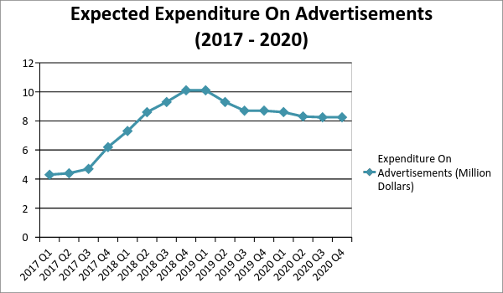

# Social Message

We are the society we live in, and our lives are defined by how much we give back to this society we take so much from.

While coming up with the recipe for our noodles, we took a step back and wondered - what will we do for the world with our noodles? How will it bring a smile on the face of that kid sitting on the street, hoping for the next morsel of food from a kind stranger?

We sat together and came to a decision: a sizeable portion of our revenue will go towards educating children and helping them get on good career paths. It’s shocking how many people are deprived of a basic right, schooling - we will take our own little steps in making this reality less harsher and more positive.

Every time you buy a Noodli packet, you are financing a young child’s year in school. Changing their life. Helping them gain footing in society and making them able enough to walk proudly, with a satisfied countenance.

Every time you’re enjoying your favourite cup of noodles, another kid out there is learning Algebra. Someone is learning about the revolt of 1857, and yet someone beginning to learn the alphabet.

Let’s bring together an educational revolution. Let’s all send kids to schools and contribute wherever possible to the upliftment and happiness of children deprived of the necessities we consider primal and basic.

Let’s take a step forward together.

